Route
Let’s head into the routes file to add a new show route so that our app recognises this new url format. Within the body of the setupRoutes() method, we can add a new route to show a single Fact. This route will use the GET action. It will also have a :id path parameter.
package main

import (
"github.com/divrhino/divrhino-trivia/handlers"
"github.com/gofiber/fiber/v2"
)

func setupRoutes(app *fiber.App) {
app.Get("/", handlers.ListFacts)

app.Get("/fact", handlers.NewFactView)
app.Post("/fact", handlers.CreateFact)

// Add new route to show single Fact, given `:id`
app.Get("/fact/:id", handlers.ShowFact)
}
We are referencing the ShowFact handler that does not exist yet. We can create that next.
Handler
Within the handlers package, we will create the ShowFact handler that will retrieve and render a single fact.
As with all handlers in Go Fiber, we pass in the context and return an error. Then within the body of the ShowFact handler, we create a new variable called fact to store a Fact model instance to hold the fact we will retrieve.
To be able to retrieve the Fact from the database, we will need to know its id. We can use the c.Params() method to pull this information from the URL.
A typical URL will look something like this:
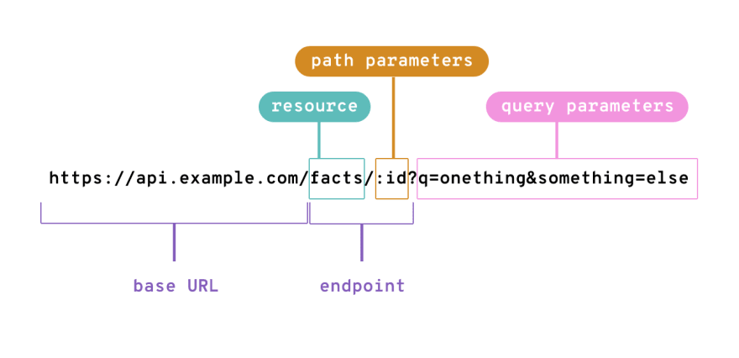
We use Go Fiber’s c.Params() method when we’re specifically trying to get values from the path parameters. So c.Params("id") would get us the id value from the above example URL.
Once we have the id value, we can use it to query the database and get the First record where the id matches.
Then we can use the c.Render() method to render a frontend view.
func ShowFact(c *fiber.Ctx) error {
fact := models.Fact{}
id := c.Params("id")

database.DB.Db.Where("id = ?", id).First(&fact)

return c.Render("show", fiber.Map{
"Title": "Single Fact",
"Fact": fact,
})
}
Let’s use the frontend views we already have to add a new Fact. If we try to view this newly-created Fact in our browser, we get the following error:
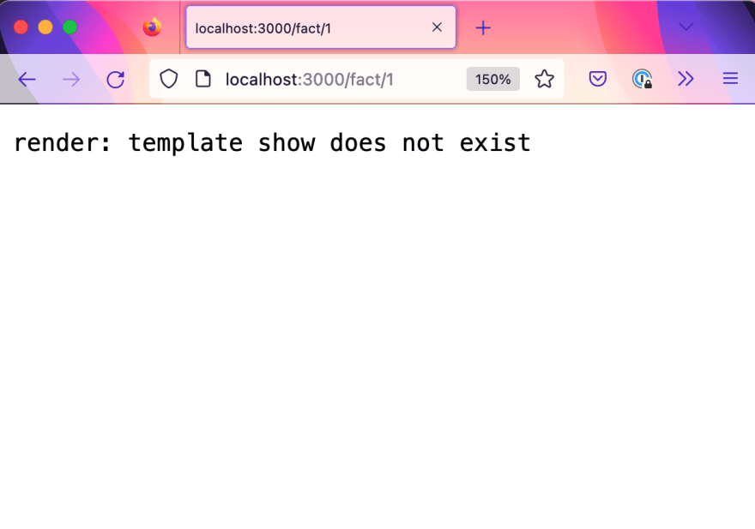
We can fix this by creating a new template called show:
touch views/show.html
Then within this view/show.html file, we can add some markup. The classes used in this markup correspond with styles that have been pre-prepared in the CSS. We will not go into depth about them, as CSS is out of scope for this tutorial.
<div class="container flex">
{{if .Fact}}

<div class="content">
<p>{{ .Fact.Question }}</p>
<p>{{ .Fact.Answer }}</p>
</div>

<div class="actions">
<a href="" class="btn-secondary">Edit</a>
<button class="btn-danger">Delete</button>
</div>
{{end}}
</div>
We use an {{if}} block to check for the presence of a Fact and conditionally display content. If a Fact exists, we will render it along with an Edit link and a Delete button. If we head into the browser now, we should be able to see our single Fact being displayed by the show template.
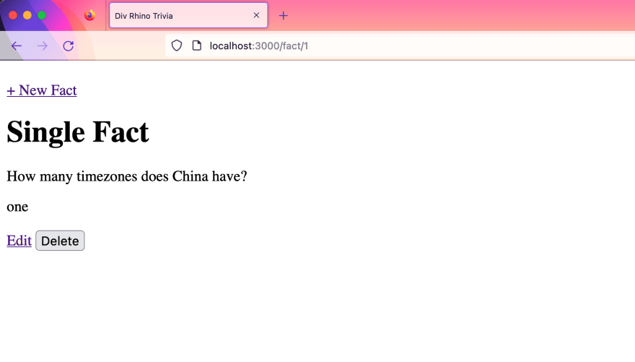
However, you may notice that none of our CSS styles are being applied to this page. We can quickly fix this by heading into our view/layouts/main.html file and update the link to our stylesheet so that is has a preceding / in the path. So it should look like this:
<link rel="stylesheet" href="/style/main.css?v=1">
And if your logo image is also missing, we can fix this by heading into the views/partials/header.html file and update the link to our image so that is has a preceding / in the path. So it will look like this:
<img src="/image/divrhino-logo.png" alt="">
Now when we refresh the browser, we should see our styled show page
